Steps to follow to Create UI5 Fiori App using VSCode. Basically setting up the VSCode Environment.

Will Later Update this docx with .md file.

1. Download and install VSCode any latest one.
2. Download and install Node-Js. I’m Using node 18.17.1.
3. Go to your workspace directory and **open vscode in that directory.**
4. **npm install** in your **workspace directory** of UI5.
5. GO to extension of VSCode and search & Install **SAP Fiori Tools - Extension Pack**

All tools inside that will get installed  
these tools helps us in our Fiori UI5 development.

Restart your visual code.

1. Ctrl + shift +p : **write Fiori open application generator** and select that option from search cmd pallet:
2. Select basic template from tiles click next.
3. Select None into data source as this is basic application.
4. Next is **Entity Selection : Default it will be View1: I am using Home**
5. Next is **Project Attributes: I am using as shown below**
6. 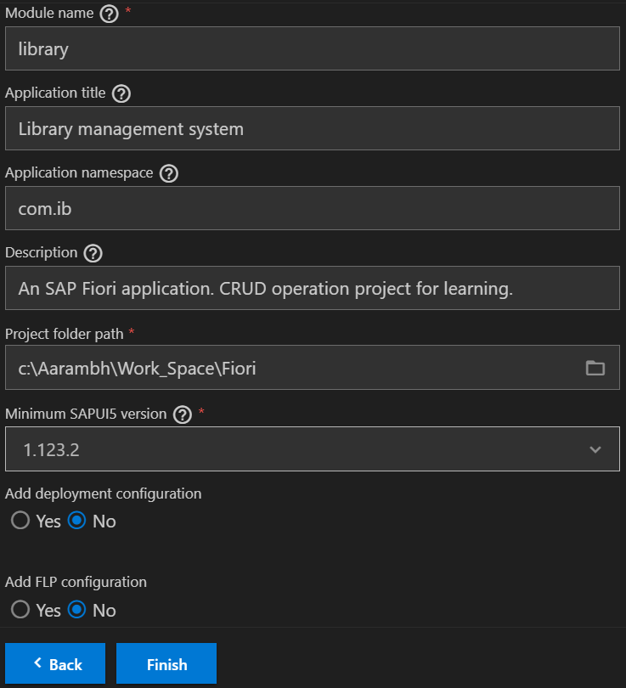
7. Click finish: it will say: installing dependencies wait:
8. 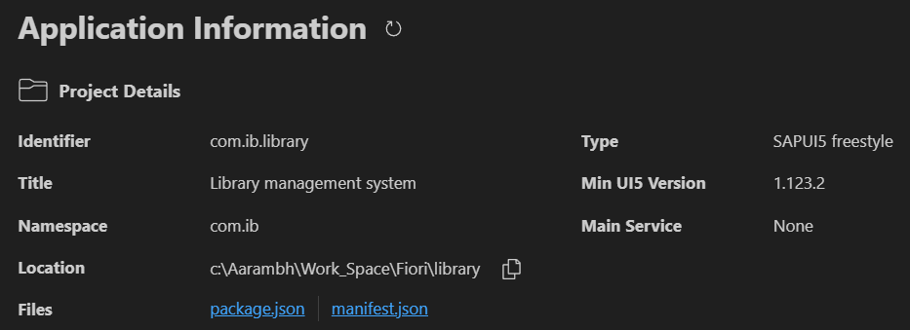
9. Once completed it shows like this so your app is built and now you can work on the code changes.
10. Now Some Notes time:
    1. Module Name is = Project Name
    2. Go to controller you will find namespace being used **com.ib**
    3. **Now Explore the File Path and files which file is being used for what**
11. **Run Application: Right click on app: preview application: start**
12. **It will launch a terminal and show the localhost port where application is being run.**

---------------------------------------------------------------------------------------------------------------------------------------------------

Now let’s build a small app: Library Management system:

* What we will try to do first:  
  1. Create Three button in Home page:
  + View All Book
  + Add Book
  + Find Book
* So first step is always to create a model in this case it will be **Book**.

Note:  
Certain Rules to be followed during routing:  
1.

        {

          "name": "ViewBooks",

          "pattern": "ViewBooks",

          "target": "TargetViewBooks"

        }

"TargetViewBooks": {

          "viewType": "XML",

          "transition": "slide",

          "viewId": "ViewBooks",

          "viewName": "ViewBooks",

          "viewLevel": 2

        }

2. Route Name should be same as View Name.

3. pattern should be same as View Name.